Chapter 17, Problem 38.

If the square wave shown in Fig. 17.74(a) is applied to the circuit in Fig. 17.74(b), find the Fourier series for v_{o}(t).

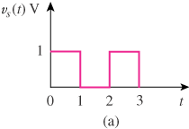

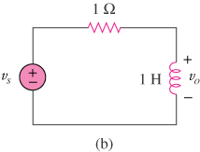

Figure 17.74
For Prob. 17.38.

